We are Bonded and Insured

We listen and that means we find solutions that are tailored to your needs.

We appreciate the opportunity to earn your business.

We have been proudly serving Central Florida since 2007.

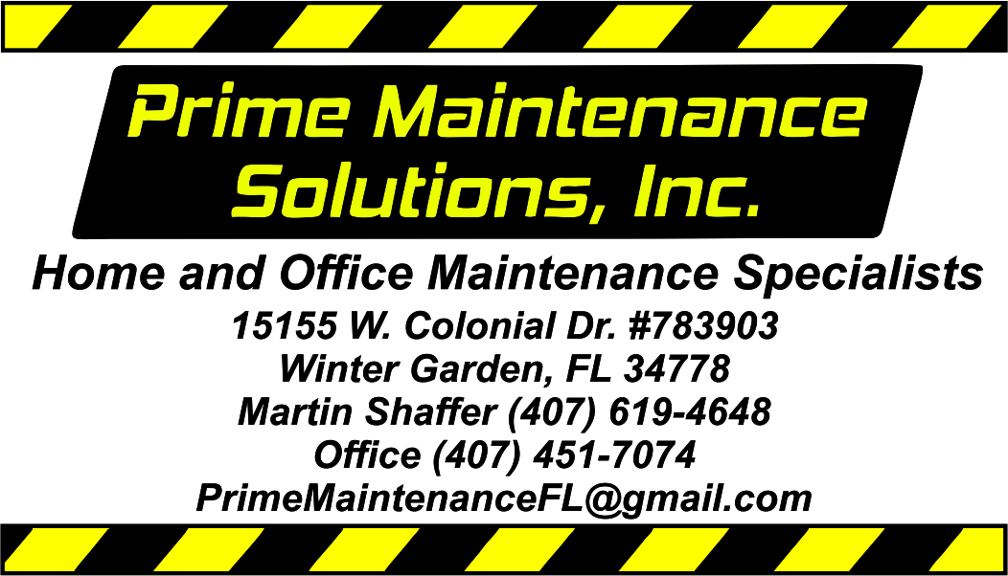

Our Central Florida service area covers: Solivita to Deltona and from Bithlo to Mascotte

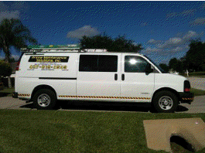

[your-url-goes-right-here.com](http://www.your-url-goes-here.com)

We

We help you preserve your Home, Office, and Rental property values.

* Let us complete your “to-do” list
* We give you more free time to do the things you enjoy
* Quality Home improvements and repairs at reasonable rates
* Commercial
* Residential
* Assistance with HOA violation and code enforcement compliance



*NARPM Preferred Partner Member*

Our regular business hours are

Monday through Friday from

8:00 AM to 5:00 PM EST.

**We provide services on a time and materials basis.**

**Labor is billed at a rate of $70 per hour (minimum charge of 1 hour).**

Full payment is expected at time of service unless otherwise indicated.

We also accept payments online to save time and provide you with a digital receipt for your records.

PMSI takes a different approach to maintenance; one that is built on personal touches, win-win ideas and positive results.

Let us exceed your expectations!

Please Call 407-451-7074 or Email us at [PrimeMaintenanceFL@gmail.com](mailto:PrimeMaintenanceFL@gmail.com) and let our courteous staff schedule your **appointment.**



We are honored that you have chosen us to help you with your maintenance needs.

**We ♥ referrals**

<https://www.facebook.com/PrimeMaintenanceSolutionsIncorporated>

<https://www.youtube.com/channel/UCtM5K8H5b7IdYXgMOFFC7tw>

<http://www.primemaintenancesolutions.com/>

A current copy of our General Guidelines and Brochure can be found on our website.

**The listed services are representative of the services we provide, but by no means are meant to limit the scope of all that we do or are capable of doing. Please contact us to discuss your specific needs.**

**Additional Services Offered**

* Carpentry
* Ceiling repair
* Countertops
* Crown Molding and trim work
* Curtain hanging
* Door repairs-interior, exterior, and door frame replacements.
* Door repairs- interior and exterior door slab replacements
* Minor drain cleaning
* Dryer vent cleaning
* Dryer vent installation
* Drywall Installation
* Drywall repair
* Fan installation
* Minor Framing
* Garage door openers
* Garage door coil torsion spring replacement
* General Maintenance
* Lamp repairs
* Lockset adjustment
* Molding installation
* Minor pest control
* Safety Modifications
* Minor Senior living modifications
* Pet access door installation
* Shelf installation and repair
* Shelving
* Waste and Junk removal

**General**

* Appliance Installations & Disposal
* Trash Out/Debris Removal
* Turn Key/Punch Lists
* Preparing Homes for Sale
* Sheetrock/Plaster Installations & Repairs
* Tile & Laminate Installations & Repairs
* **Aerial Videography, Mapping & Photography**
* **FAA Registered Drone Flown by a FAA Certified Commercial Part 107 SUAV Pilot**

**Exterior Maintenance**

* Minor Concrete/Masonry Repairs
* Minor Driveway Patching & Sealing
* Fences/Gates Installations & Repairs
* Glass/and Side Screen Installations, Replacements & Repairs
* Gutters/Downspouts Repairs
* Minor Landscaping Repairs & Restorations
* Painting (both exterior & interior)
* Window and Door Repairs
* Sprinkler repair
* Porch repair
* Gutter cleaning
* Minor landscaping
* Minor siding repair
* Decorative mulch removal and installation
* Pressure Washing
* Screen door installation



**Construction & Remodeling**

* Attic –plywood flooring for storage
* Minor Bath Room Remodeling
* Minor Cabinets/Countertops Installations, Replacements & Resurfacing
* Repair of Garages & Carports
* Minor Kitchen Remodeling
* Repair of Sheds & Storage Buildings